Task 4: Develop Detailed Strategy

for:
ASHRAE 1449-RFP
Energy Efficiency and Cost Assessment of
Humidity Control Options for Residential Buildings

by:
Building Science Corp.
CDH Energy Corp.
University of Central Florida / Florida Solar Energy Center

08 September 2010

TABLE OF CONTENTS

1. Introduction 3
2. Simulation Plan 4
Overview 4
Space Conditioning Systems 5
Whole-building Mechanical Ventilation 11
Climates 15
Building Size and Foundation Type 15
Building Enclosure Thermal Performance 16
Building Enclosure Air Leakage 16
Duct Air Leakage 16
Internal Heat and Moisture Generation 17
Summary of Building Characteristics, Air Leakage & Internal Gain Combinations 18
3. Summary of Parametric Cases 18
4. References 19
Appendix A. Detailed Description of Building Efficiency Levels 20
Appendix B. Detailed Summary of Parametric Simulation Cases 25

Introduction
Task 1 of this research project detailed the current state of the art in dehumidification options used in the residential space conditioning industry through an extended literature search. Gaps in equipment performance information were identified in some cases, but mostly regarding inverter-driven variable refrigerant flow systems (mini- and multi-split ductless systems) that are becoming more common in recent years. Efforts to obtain more detailed information to allow accurate modeling of those systems are ongoing. Those systems typically have multiple control states and may operate at multiple state points in each control state.

Task 2 developed a list of the critical questions to be answered throughout the rest of this project. These questions focused the scope of work needed to accomplish the stated objective of this research -- to evaluate, assess and rank the humidity control performance, energy efficiency, and cost of space conditioning systems for their capability to control indoor humidity throughout the year in humid climate residences, with a reference humidity control target level of less than 60% relative humidity.

Task 3 identified the model development needs that must be addressed in order to meet the objectives of this research effort. The most important of those areas related to the ability to properly model: variable speed ductless air conditioning systems and ducted two-speed systems; cooling systems using full condensing reheat; moisture evaporation for dehumidifiers that integrate ventilation; and full accounting for the combined effects of unbalanced duct leakage, unbalanced ventilation, and infiltration. More recent discussions have also indicated the need to upgrade the infiltration model to incorporate the methodology developed by Walker and Wilson (Walker and Wilson 1998, ASHRAE 2009). These model improvements will be implemented (during Task 5) to provide more accurate and meaningful simulation results. These improvements are necessary to accurately represent integrated building/equipment performance so that the predicted performance of the different systems can be meaningfully compared.

This Task 4 report defines the detailed strategy to be used for completing the simulations in Task 5. This modeling plan was developed to optimally reduce the uncertainty of answers to the crucial questions identified in Task 2. The strategy includes using a range of comfort conditions and moisture loads to assess the reported success or failure of evaluated humidity control options.

Simulation Plan

Overview

The project simulation plan defines the strategy for completing a detailed evaluation of the identified air conditioning and dehumidification systems in multiple climates and with various sets of assumptions for house construction, building leakage, and ventilation. Measured data from the USDOE Building America program, consisting of field and lab testing data on equipment performance and indoor environment conditions, is available for comparison with the simulation results. The simulation results will be documented in such a way as to rank the systems according to specific criteria of humidity control performance, overall energy efficiency, moisture removal efficiency, first cost, operating cost, and identification of probable successes and problems.

TRNSYS will be used as the computer modeling software for this project. Specifically, TRN-ResDH, previously developed by Hugh Henderson and improved (during Task 5) as described in the Task 3 report, is a TRNSYS-based hour-by-hour building energy simulation tool, and will be used to simulate the HVAC technologies being investigated as part of this project. TRN-ResDH includes component models for various dehumidification systems of interest in this study, including conventional standalone room air dehumidifiers, high-efficiency mechanical dehumidifiers, subcool and full-condensing condenser reheat systems, and desiccant dehumidification equipment. It also includes robust models for conventional AC components that accurately predict performance at part-load conditions. The impact of moisture capacitance in building materials and furnishings, moisture evaporation from the cooling coil when the compressor is off, and other impacts of fan performance are all considered in this simulation tool. As a result, this short-time-step (0.02 hr) tool properly considers all of the system control and performance factors that are critical to predicting energy consumption and resulting indoor humidity conditions.

Subject to review and approval by the ASHRAE Project Management Subcommittee, the rest of Section 2 of this report defines the parameters used to create the matrix of simulations to be performed as part of this research project. A summary of the parametric cases is provided in Section 3 of this report.

Space Conditioning Systems
The study will consider both conventional cooling systems as well as enhanced cooling systems that provide slightly better humidity control. Explicit cooling and dehumidification systems that actively control indoor humidity levels in response to a humidistat will also be evaluated. Information regarding control set points, system sizing, and specific parameters for each system are described in the following paragraphs. A summary of all cooling/dehumidification systems being evaluated as part of this project is provided further below in Table 1.

Thermostat setpoints will be: 70 F heating for CZ 3, 4, 5; 72 F heating for CZ 1, 2; and 78 F cooling for all CZ per the HERS Reference House according to the 2006 Mortgage Industry National Home Energy Rating Systems Standards.

For explicit cooling/dehumidification systems, such as dehumidifiers, the year-round high humidity control target will include two different levels (50% and 60% relative humidity) to consider two levels of interest often considered by different industry groups. These systems will be controlled by a humidistat with deadband. For the control target of 60% RH, explicit dehumidification performance will be activated at 59% RH and deactivated at 57% RH (e.g., a set point of 58% ±1%). Similarly, for the control point of 50% RH, explicit dehumidification performance will be activated at 49% RH and deactivated at 47% RH.

The enhanced humidity control systems – which change unit performance when humidity is high but still continue to cycle based on thermostat control – will be activated when the relative humidity is within 5% of the desired humidity target level. So if the desired control level is 60% RH, the humidity control enhancement (e.g., lower airflow across the cooling coil) will be enabled when the space starts to approach the control point (i.e., above 55% RH). This control method will limit high humidity excursions above the control target (e.g., 60% RH) and allow a more direct comparison between the enhanced and explicit humidity control systems.

Overcooling – which is in between enhanced and explicit control – will be engaged by a reset schedule (e.g., the overcooling setting will increase from 0 to 2F as the RH increases from 55% to 59% RH.

All conventional space conditioning systems will be sized according to ACCA Manuals J (8th edition). For heating or cooling loads that fall below the smallest available systems, the smallest available system size will be used.

The 14 cooling and dehumidification systems of interest that were identified for evaluation in the Task 1 report are listed below. Specific details are given for each system.

SYSTEM 1 – Conventional DX System. A conventional, single speed DX air conditioner (air-cooled condenser) with a PSC fan motor (SEER 13). The system has a “gross” EER of 13.8 Btu/Wh at Rated Conditions. The system will operate at a supply airflow rate of 375 cfm/ton with corresponding supply air fan power of 0.5 Watts/cfm.

SYSTEM 2 – Conventional DX System with Lower Air Flow and Thermostat Overcooling. Same as SYSTEM 1 above but with controls to provide lower airflow (down to 200 cfm/ton) and space overcooling (as much as 2°F below setpoint) when space humidity is high (i.e., above the target humidity level as described above). When in the overcooling mode (i.e., operating below the cooling dry-bulb temperature setpoint), compressor operation is limited to 50% runtime (10 minutes on, 10 minutes off). The operating fan power for PSC motor fans will range from 0.3 to 0.5 W/cfm between low and high airflow. The operating fan power for brushless permanent magnet (BPM) motor fans will range from 0.1 to 0.4 W/cfm between low and high airflow.

SYSTEM 3 – Two-Speed Conventional DX System. A two-speed AC unit with a gross EER of 13.5 Btu/Wh at high speed and approximately 14.5 Btu/Wh at low speed. The system characteristics will be selected to achieve an SEER of 16-18. The operating supply air fan power with the ECM motor is 0.4 W/cfm at 375 cfm/ton for high speed. Low speed maintains the same cfm per “delivered ton” with 0.2 Watt/cfm.

SYSTEM 4 – Variable Speed Mini-Split DX System. A variable speed ductless air conditioner unit with the ability to modulate air flow independently of compressor speed. The system characteristics will be selected to achieve an SEER of 20-22. The operating fan power is 0.1 W/cfm at 375 cfm/ton for high speed compressor operation (Larson 2010). Lower compressor speeds allow for a lower supply air flow rate per “delivered ton” with correspondingly lower fan power.

SYSTEM 5 – Stand-Alone Dehumidifier with Conventional System Mixing. Small (40-50 pint/day) portable stand-alone DX dehumidifier with an Energy Factor (EF) of 1.55 liters/kWh at AHAM rating conditions . The dehumidifier will operate to maintain the high humidity target independently of the conventional (SEER 13) air conditioner. Controls will ensure that the conventional AC supply air fan runs at least a few (e.g., 10) minutes out of every hour to provide mixing in the space (to provide a minimum zone air mixing rate of 0.7 ACH).

SYSTEM 6 – Ducted Dehumidifier with Conventional System Mixing. Larger DX dehumidifier (65 pint/day, EF=1.9) with an EF of 1.9 liters/kWh at AHAM rating conditions, integrated with a Conventional 13 SEER AC unit (SYSTEM 1) in a recirculation configuration (pulling air from the main zone and supplying air into the AHU supply duct). The dehumidifier compressor and fan operate in response to the humidity set point. The equipment performance map will be scaled from the same brand 150 pint/day unit that was tested in the NREL HVAC lab. Airflow through the dehumidifier is published at 190 cfm at 0.0 inch w.c. However, to reflect the extra fan power for this ducted system, data provided by the manufacturer will be used (Thermastor 2010). The dehumidifier airflow is 120 cfm when the central air handler unit is not running at the same time (i.e. 0.4 inch w.c.) and 100 cfm when the central air handler unit is running at the same time (0.6 inch w.c.). The total unit power is published at 680 W operating at the rating condition of 80 F and 60% RH, but the fan power is not provided separately. After communicating with the manufacturer about this, the normalized fan power for the dehumidifier unit is assumed to be 0.6 Watt/cfm. Controls ensure that the conventional AC supply air fan runs at least a few (e.g., 7) minutes out of every hour to provide mixing in the space (minimum zone air mixing rate of 0.5 ACH) for consistent indoor humidity uniformity comparison between systems.

SYSTEM 7 – Ducted Dehumidifier with Outdoor Air Preconditioning. Larger DX dehumidifier (65 pint/day) with an EF of 1.9 liters/kWh at AHAM rating conditions, integrated with Conventional 13 SEER AC unit (SYSTEM 1) in a ventilation air pre-conditioning configuration. The dehumidifier fan operates to bring in both return and ventilation air at a ratio of 2 to 1 (100 cfm recirculation air to 50 cfm outside air). At a minimum, the dehumidifier fan will operate for the portion of each hour that is required to provide the required ventilation airflow. The supply air from the dehumidifier unit is discharged into the AC supply duct. The outdoor air ventilation intake is controlled by a motorized damper to limit ventilation flow to the required amount for each hour (after required ventilation is provided, the damper closes and further operation of the dehumidifier for high humidity control for that hour will be with 100% recirculated air). The dehumidifier compressor and fan operate in response to the humidity set point. The equipment performance map will be scaled from the same brand 150 pint/day unit that was tested in the NREL HVAC lab. Airflow through the dehumidifier is published at 190 cfm at 0.0 inch w.c. However, to reflect the extra fan power for this ducted system, data provided by the manufacturer will be used (Thermastor 2010). The dehumidifier airflow is 120 cfm when the central air handler unit is not running at the same time (i.e. 0.4 inch w.c.) and 100 cfm when the central air handler unit is running at the same time (0.6 inch w.c.). The total unit power is published at 680 W operating at the rating condition of 80 F and 60% RH, but the fan power is not provided separately. After communicating with the manufacturer about this, the normalized fan power for the dehumidifier unit is assumed to be 0.6 Watt/cfm. Controls ensure that the conventional AC supply air fan runs at least a few (e.g., 7) minutes out of every hour to provide mixing in the space (minimum zone air mixing rate of 0.5 ACH) for consistent indoor humidity uniformity comparison between systems.

SYSTEM 8 – Enhanced Cooling with Partial-Condensing/Subcooling Reheat. Central DX cooling system with refrigerant subcooling/reheat coil. Based on the two-speed AC unit (SYSTEM 3) described above, but with enhanced mode operation when humidity is high (i.e., control scheme based on Lennox Humiditrol system). Specifics regarding this system’s dehumidification operating mode are provided in the Task 1 report (Section 4.4.1).

SYSTEM 9 – Enhanced Cooling with Full Condensing/Subcooling Reheat. Central DX cooling system with modulating hot gas reheat providing full condensing and subcooling at an indoor reheat coil. Based on the two-speed AC unit (SYSTEM 3) but with slightly higher fan power to reflect impact of added reheat coil (0.45 Watt/cfm at high speed; 0.22 Watt/cfm at low speed) (Ueno 2010). Specifics regarding this system’s dehumidification operating mode are provided in the Task 1 report (Section 4.4.2).

******* Sensitivity studies only for the following systems

SYSTEM 10 - Conventional DX System with Lower Air Flow. Same as SYSTEM 1 above but with controls to provide lower airflow (down to 250 cfm/ton) when space humidity is high (i.e., high humidity control as described above for “enhanced” humidity control systems).

SYSTEM 11 - Conventional DX System with Thermostat Overcooling. Same as SYSTEM 1 above but with controls to allow for space overcooling (as much as 2 F below cooling dry-bulb temperature setpoint) when space humidity is high (i.e., using the reset schedule described above).

SYSTEM 12 – Conventional DX System with Sensible-Only AAHX. Conventional DX cooling system (SEER 13) with sensible air-to-air heat exchanger (AAHX) added for improved dehumidification performance (e.g., heat pipes). The heat pipe is assumed to be a non-condensing, aluminum fin, 1/2 inch O.D. copper tube, 2 row, 12 fpi, coil with 350 ft/min face velocity (face area approximately equal to the AC tonnage), temperature effectiveness = 0.334, and air static pressure drop=0.238 inch w.c. (Heat Pipe Technology 2010). Operating fan power increases to 0.55 Watt/cfm at 350 cfm/ton to account for the additional heat exchanger pressure drop compared to SYSTEM 1.

SYSTEM 13 – Conventional DX System with Gas-Regenerated Desiccant Dehumidifier. Conventional DX cooling system (SYSTEM 1) with gas-regenerated desiccant dehumidifier (e.g., NovelAire ComfortDry 400). The unit pulls in regeneration air from outdoors and then exhausts it back to outdoors. The 400 cfm unit has a dehumidification capacity of 6.3 lb/h (145 pint/day) at AHAM rating conditions. The process side of the desiccant unit is arranged to pull air from the supply duct (downstream of the cooing coil) and provide dehumidified process air back to the AC supply duct. The process (or supply) fan power is 240 Watts (0.6 Watt/cfm). Controls ensure that the conventional AC supply air fan runs at least a few (e.g., 7) minutes out of every hour to provide mixing in the space (minimum zone air mixing rate of 0.5 ACH). To account for the cost of gas and electric use for desiccant regeneration, the EIA average gas and electric rates are used for each applicable State (http://tonto.eia.doe.gov/dnav/ng/ng_pri_sum_a_EPG0_PRS_DMcf_m.htm).

SYSTEM 14 - DX Condenser-Regenerated Desiccant Dehumidifier. Conventional DX refrigeration cooling system (13 SEER) along with a desiccant system regenerated by condenser waste heat from its small internal compressor (e.g., Munters HCU or the NovelAire 300). The Munters DryCool HD unit’s dehumidification capacity is about 5.2 lb/h at 250 cfm (120 pints per day). The unit’s energy factor is 3.3 liters/kWh (excluding supply fan power). The supply fan is estimated to be 250 cfm at 175 Watts (0.7 W/cfm). Controls ensure that the conventional AC supply air fan runs at least a few (e.g., 7) minutes out of every hour to provide mixing in the space (zone air mixing rate of 0.5 ACH). A performance map for the this desiccant unit has been developed data from the software tool available from the Munters/ DryCool HD website (version 1.0.4.0).

Figure 1 below schematically shows the configuration for the more complicated systems. We have generally assumed that ducted dehumidifiers and desiccant systems will supply air into the supply trunk of the main air handler unit (AHU). This helps to distribute dehumidified air throughout the house. However, practical experiences with these systems have shown that some AHU fan operation will still be required to provide adequate air distribution. Therefore, the supply air fan will be required to operate for a minimum fraction of each hour to provide a desired air mixing rate for the space. We will use a minimum mixing rate of 0.7 ACH for the standalone dehumidifier (SYSTEM 5) and 0.5 ACH for the ducted dehumidifier and desiccant systems (SYSTEMS 6, 13, 14).
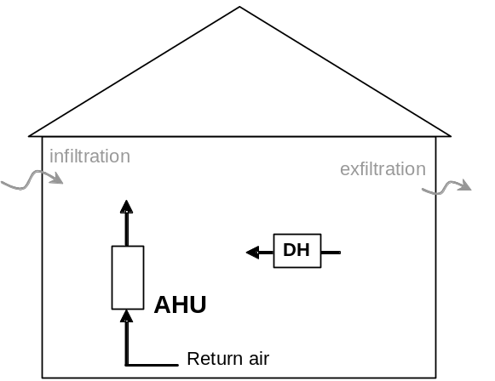  Stand-Alone Dehumidifier (SYSTEM 5)  (AHU for mixing; 0.7 ACH minimum) | 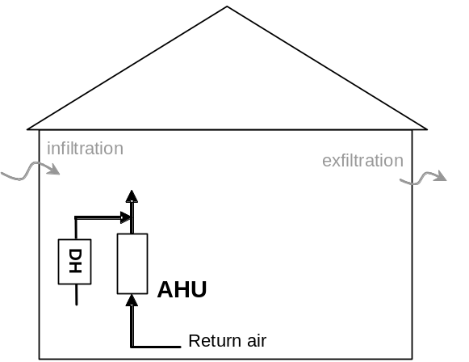  Ducted Dehumidifier (SYSTEM 6)  (AHU for mixing; 0.5 ACH minimum)
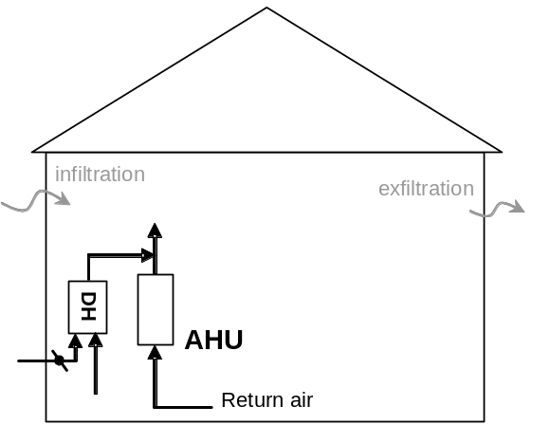

Ducted Dehumidifier with OA (SYSTEM 7)
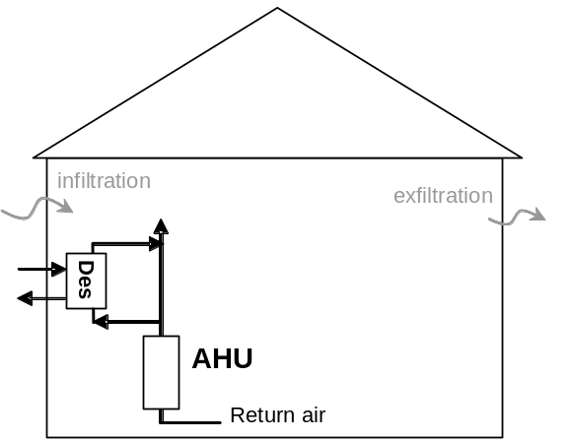  Gas-Fired Desiccant DH (SYSTEM 13)  (AHU for mixing; 0.5 ACH minimum) | 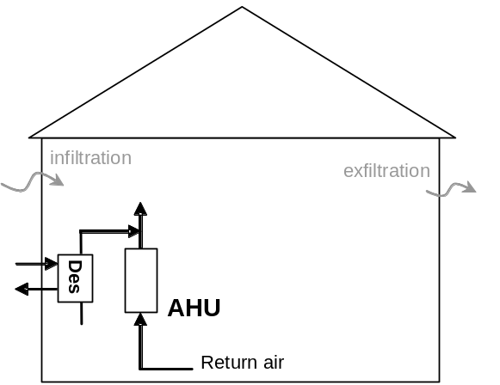  Desiccant Dehumidifier (SYSTEM 14)  (AHU for mixing; 0.5 ACH minimum)

Figure 1. Schematic of Configuration for Various Space Conditioning Systems
Ducting the dehumidifier units into the main supply air trunk, as shown in the schematics in Figure 1, results in different airflow rates when the two machines operate separately or together. When both machines operate together the total duct flow increases by 20 to 30%, which results in a 40 to 70% higher static pressure imposed on both units. As a result, the airflow rate through both machines will be reduced, changing unit performance and fan power. While the performance of the conventional AC unit at low air flow is well understood, there is
less data available on dehumidifier performance at low air flow. We intend to track the operation of each machine and change the unit airflow, fan power, and thermal performance depending on the operating state of the other machines. For the dehumidifier and desiccant units we will use simple degradation factors to adjust performance based on findings with generic models (e.g., Keith Rice’s DH version of HPDM).

Local Exhaust Ventilation
Local exhaust fan use will be modeled for each house. Local exhaust fan use for bathroom and kitchen is modeled as 50 cfm from 7 am to 7:30 am, 100 cfm from 5 pm to 5:30 pm, and 50 cfm from 9 pm to 9:30 pm.

Whole-building Mechanical Ventilation
Whole-building mechanical ventilation will be modeled at the rate required by ASHRAE Standard 62.2 for all cases, except the HERS 130 house will be modeled with no whole-building mechanical ventilation. A sensitivity study will be conducted using 50% and 150% of the rate required by ASHRAE Standard 62.2 for the HERS 100 and HERS 70 houses, for climate zones 2A and 4A.

Three different mechanical ventilation options will be considered. Figure 2 shows the configuration of each system.

Exhaust Only. The exhaust fan runs 100% of the time (independent of the AC unit) to provide the necessary ventilation for the house. The exhaust fan power is assumed to be 0.4 Watt/cfm.

Supply – Central Fan Integrated. A fresh air damper is installed on the return side of the air conditioner. The supply air fan runs a minimum of 33% of each hour (at heating speed, fan power is assumed to be 0.4 Watt/cfm) (Ueno 2010) to provide the necessary ventilation for the house. The fresh air damper is open during fan operation for no more than 33% of each hour. No exhaust fan is used.

Balanced Ventilation – ERV/HRV. An Energy Recovery Ventilator (enthalpy wheel) or Heat Recovery Ventilator (sensible heat exchanger) is installed to provide balanced ventilation (ERV: 70% sensible effectiveness; 60% moisture effectiveness; HRV: 75% sensible effectiveness). The airflow through the ventilator will be twice the ventilation requirement but the fans will run only 50% of each hour, initiated at the top of the hour. The fan power will be 0.5 Watt/cfm (each side). The ERV/HRV pulls exhaust air from the return side of the central air distribution system and supplies tempered fresh air back to the return duct (see Figure 2). The AC supply air fan will run coincident with (interlocked with) the HRV/ERV fan to avoid short-circuiting of ventilation air. If during ERV/HRV operation the AC supply fan is also required to operate for heating or cooling, then the AC supply fan will operate at that required speed, otherwise, it will operate at the lowest available speed. We will apply ERVs in climate zones 1A, 2A and 3A and HRVs in climate zones 3A, 4A, and 5A.

These mechanical ventilation options will be implemented for the 14 SYSTEMS as shown in Table 1. However SYSTEM 7, which provides outdoor ventilation air on its own, does not require additional mechanical ventilation so these options will not be used. The systems with explicit humidity control can not be modeled with an HRV/ERV since TRN-RESDH does not allow for dehumidification along with ventilation preconditioning (and this combination is not likely to be used in practice).

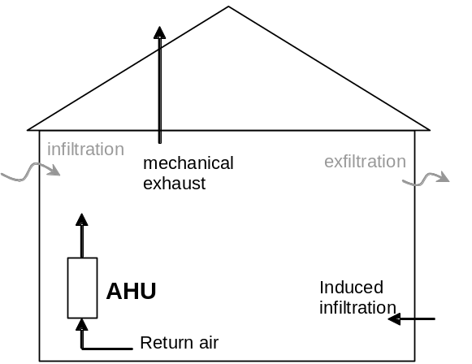  Exhaust Only  (exh fan operates 100% of hour) | 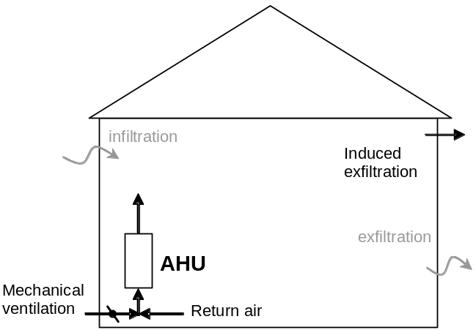  Supply - Central Fan Integrated  (damper/AHU operates 33% of hour @3xflow)
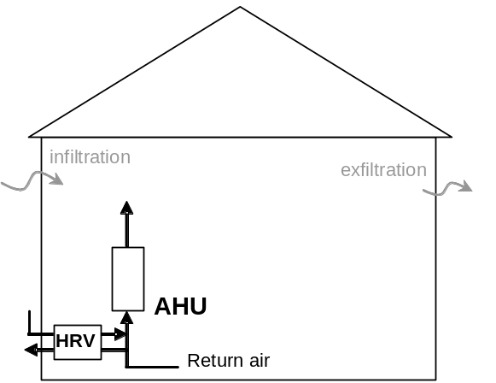  Balanced HRV / ERV – Ducted AHU  (HRV operates 50% of hour @ 2X flow) | 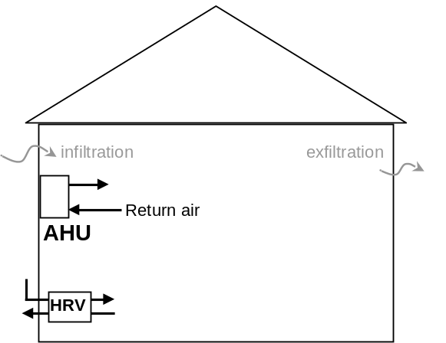  Balanced HRV / ERV – Ductless AHU (Sys 4)  (HRV operates 50% of hour @ 2X flow)

Figure 2. Layout of Mechanical Ventilation System Options
Table 1. Ventilation Options that will be Considered for Each System

No | System Description | Level of Improved Dehumidification | Ventilation Options
No | System Description | Level of Improved Dehumidification | Exhaust Only | Supply – Central Fan | Balanced ERV/HRV
1 | Conventional DX System | None | X | X | X
2 | Conventional DX System with Lower Air Flow and Thermostat Overcooling | Enhanced | X | X | X
3 | Two-Speed Conventional DX System | Enhanced | X | X | X
4 | Variable Speed Mini-Split DX System | Enhanced | X | - | X
5 | Stand-Alone Dehumidifier with Conventional System Mixing | Explicit | X | X | -
6 | Ducted Dehumidifier with Conventional System Mixing | Explicit | X | X | -
7 | Ducted Dehumidifier with Outdoor Air Preconditioning | Explicit | - | - | -
8 | Enhanced Cooling with Partial-Condensing/Subcooling Reheat (2-speed compressor) | Enhanced | X | X | X
9 | Enhanced Cooling with Full Condensing/Subcooling Reheat  (2-speed compressor) | Explicit | X | X | -
10 | Conventional DX System with Lower Air Flow | Enhanced | X | X | X
11 | Conventional DX System with Thermostat Overcooling | Enhanced | X | X | X
12 | Conventional DX System with Sensible-Only AAHX | Enhanced  (w/o control) | X | X | X
13 | Gas-Regenerated Desiccant Dehumidifier | Explicit | X | X | -
14 | DX Condenser-Regenerated Desiccant Dehumidifier | Explicit | X | X | -

Climates
The cities shown below, representing each of the IECC Climate Zones 1A through 5A shown in Figure 3, were chosen to represent locations that have, at least for part of the year, substantial latent loads, and cover a temperature range that includes both conditions with little coincident sensible load and significant coincident sensible load. TMY3 weather data is used.
IECC Zone 1A – Miami
IECC Zone 2A – Houston
IECC Zone 3A – Atlanta
IECC Zone 4A – Nashville
IECC Zone 5A – Indianapolis

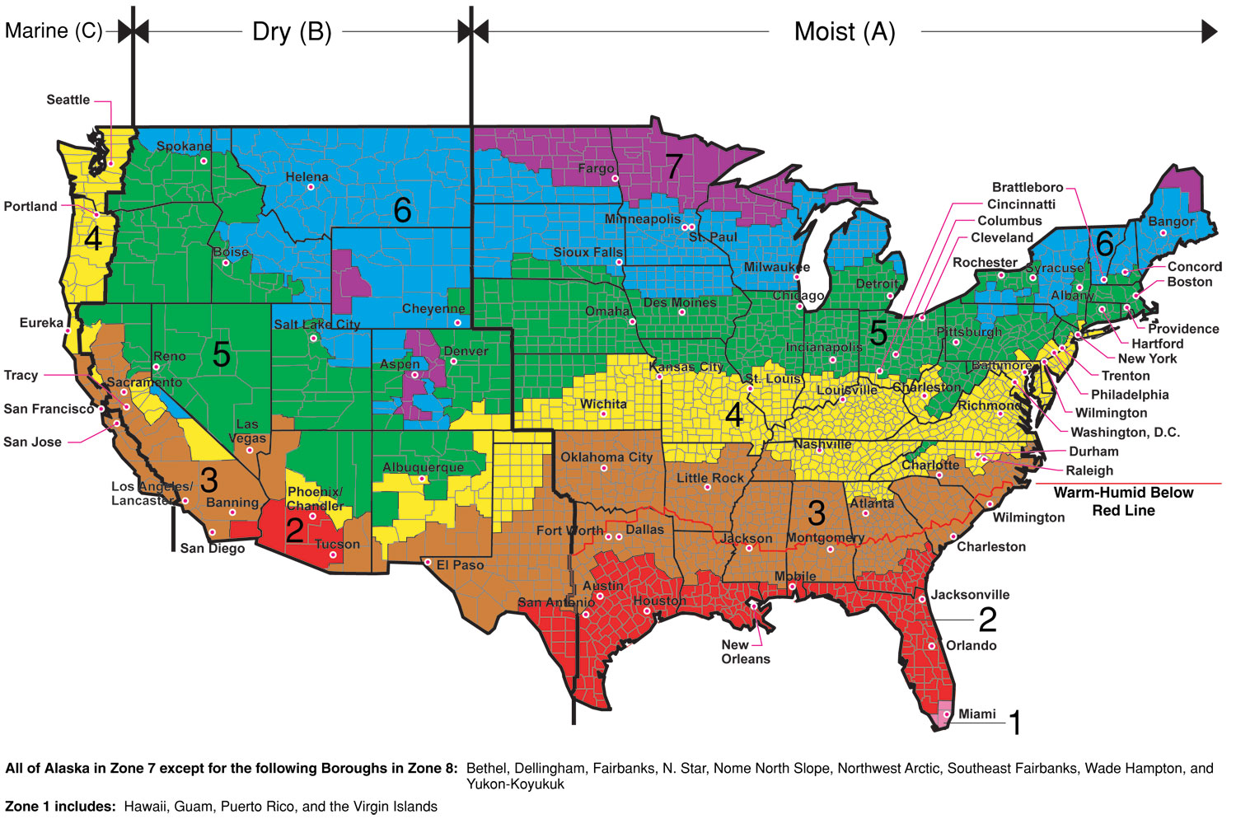

Figure 3. IECC Climate Zone map

Building Size and Foundation Type
The house foundation type will be modeled as slab-on-grade for all climate zones. A range of house sizes will be evaluated as follows:

Small — 1200 ft² conditioned floor area, 2 bedroom
Medium — 2000 ft² conditioned floor area, 3 bedroom
Large — 3500 ft2 conditioned floor area, 4 bedroom
The medium size house will be modeled for all parametric cases. A sensitivity study will be completed for the small and large size houses for the HERS Index 100 and 70 levels, in climate zones 2A and 4A, for the Conventional DX System (System 1) and the Ducted Dehumidifier with Conventional System Mixing (System 6).

Building Enclosure Thermal Performance
A range of building enclosure thermal efficiency measures that mimic known benchmarks will be modeled as follows:
Typical existing house (HERS Index≈130)
HERS Reference house (HERS Index≈100)
Energy Star house (HERS Index≈85)
USDOE Builders Challenge house (HERS Index≈70)
USDOE Building America prototype house (HERS Index≈50)
The HERS Index 70 and 50 houses will be modeled for all parametric cases. The 2-speed and variable speed systems (Systems 3 and 4) will not be modeled for the HERS 130, 100 and 85 houses. The rationale is that 2-speed and variable speed compressor systems will be 16 SEER and greater, and that level of system efficiency would generally be applied in the higher performance houses.

Building Enclosure Air Leakage
A range of building enclosure leakage rates, expressed as air changes per hour at 50 Pa pressure differential (ach50), will be linked with the levels of building enclosure thermal performance as follows:
10.0 ach50 for Typical existing home (HERS Index≈130)
7.0 ach50 for HERS Reference house (HERS Index≈100)
5.0 ach50 for Energy Star house (HERS Index≈85)
4.0 ach50 for USDOE Builders Challenge house (HERS Index≈70)
3.0 ach50 for USDOE Building America prototype house (HERS Index≈50)

Duct Air Leakage and Duct Insulation
The entire air distribution system will be modeled as being inside conditioned space for the HERS 50 house, with zero duct leakage to/from outdoors. The air distribution system will be located in the vented attic for all of the other HERS levels. Where duct leakage is non-zero, it is modeled with 40% of the leakage being on the return side of the air handler and 60% on the supply side. Duct leakage amounts will be modeled according to Table 2.
Table 2. Duct leakage amounts
HERS Level | Duct leakage percent of operational airflow | Sensitivity study at given percent leakage
130 | 20% | 5%, System 1, 6
100 | 10% | 5%, System 1,6
85 | 5% | --
70 | 5% | --
50 | none | --

A sensitivity study will be conducted for 5% duct leakage for the HERS 130 and 100 houses for the Conventional DX System (System 1) and the Ducted Dehumidifier with Conventional System Mixing (System 6).

Duct insulation is R-6 for the HERS 130, 100 houses, and R-8 for the HERS 85, 70 houses, with a sensitivity study at R-6 for the HERS 85, 70 houses. The duct R-value for the HERS 50 house does not matter because all ducts are inside conditioned space.

Internal Heat and Moisture Generation
The magnitude and scheduling of internal heat generation will be taken from the Building America Benchmark Definition (Hendron 2008). The Benchmark internal heat gain total amount is applied unadjusted for the HERS 130, 100 houses. For the HERS 85, 75 and 50 houses, the internal heat gain amount will be lower to reflect installation of more efficient lighting and appliances as follows: HERS 85 is 10% lower; HERS 75 is 20% lower; HERS 50 is 30% lower.

Internal moisture generation will modeled as 12 lb/day for the medium size house (about 50% of ASHRAE Standard 160). A sensitivity study will be conducted for 24 lb/day (about 100% of ASHRAE Standard 160) for zones 2A and 4A, for the HERS 100 and 70 houses, and for the Conventional DX System (System 1) and the Ducted Dehumidifier with Conventional System Mixing (System 6). The internal moisture gain will be scheduled throughout the day according to the Building America Benchmark Definition.

Reductions below the ASHRAE Standard 160 moisture generation rate of 31.2 lb/day (1.3 lb/h) for a 3 bedroom house can account for lower than full-time occupancy. These reductions have been shown to be realistic based on BSC comparison to monitored indoor environmental conditions.

Summary of Building Characteristics, Air Leakage & Internal Gain Combinations
The above sections describe various levels of parametric inputs defining the matrix of simulations to be performed as part of this research project. Further details regarding building enclosure thermal performance, building enclosure air leakage, internal heat/moisture generation, duct air leakage, and other assumptions regarding each of the reference efficiency levels (i.e., typical existing house [HERS Index≈130], HERS Reference house [HERS Index≈100], Energy Star house [HERS Index≈85], etc.) are provided in Appendix A.

Summary of Parametric Cases
Table 3 shows a summary of the parametric cases. The simulations to be performed include between 70 and 210 individual simulation cases for each building envelope thermal performance level (i.e., Typical Existing house, HERS Reference house, Energy Star house, Builders Challenge house, and Building America house), totaling nearly 800 simulation cases. In addition, six sets of sensitivity studies are proposed to investigate a particular area of interest, totaling just over 300 additional simulation cases. Specifics regarding each series of simulation cases (5 building envelope thermal performance levels and 6 sensitivity studies) are provided in Appendix B.

Table 3. Summary of parametric simulation cases

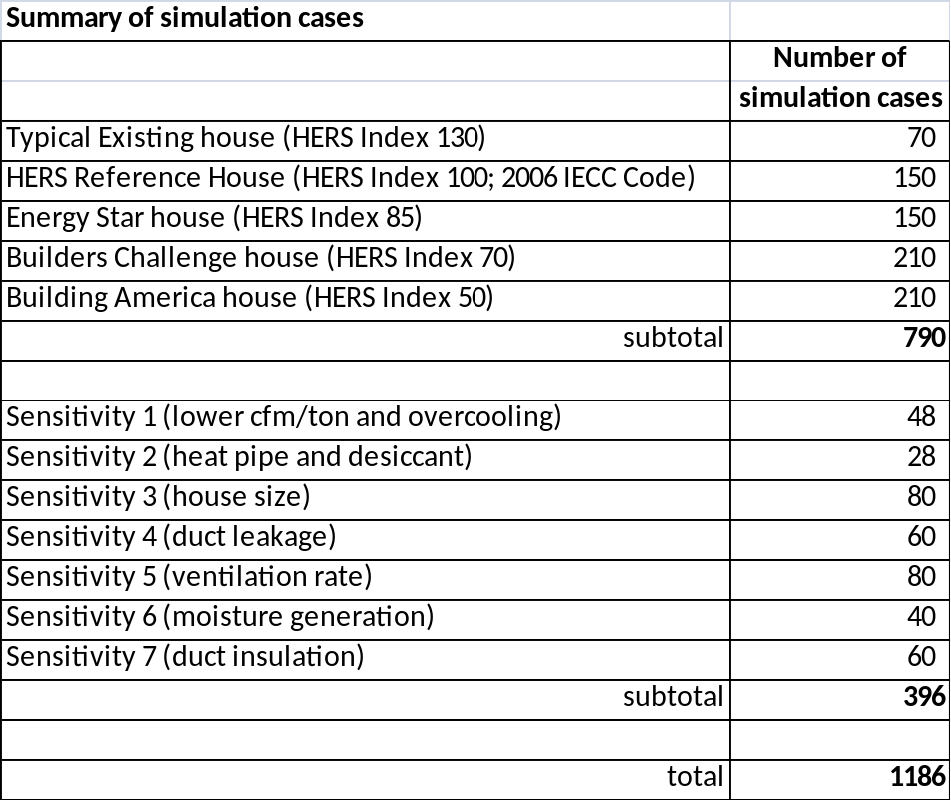

References
ASHRAE. 2009. 2009 ASHRAE Handbook – Fundamentals, Chapter 16 (Ventilation and Infiltration), pp. 16.23-16.24. Atlanta, GA: American Society of Heating, Refrigerating and Air-Conditioning Engineers, Inc.
Christensen, D. and J. Winkler. 2009. “Laboratory Test Report for ThermaStor Ultra-Aire XT150H Dehumidifier.” NREL Technical Report, NREL/TP-550-47215, Golden, CO: National Renewable Energy Laboratory.
Heat Pipe Technology 2010. “THE DHPTM SERIES Dehumidifier Heat Pipes.” Engineering Manual, Heat Pipe Technology, Inc., Gainesville, FL.
Hendron, R. 2008. “Building America Research Benchmark Definition.” Technical Report, NREL/TP-550-44816, Updated December 19, 2008, National Renewable Energy Laboratory, Golden, CO.
Larson, B. 2010. Informal data exchange from test run on a mini-split system at Purdue University, Herrick Labs. Ecotope Inc., Seattle, WA.
Thermastor 2010. Email communication with factory engineers. Therma-Stor LLC, Madison, WI.
Ueno, K. 2010. ECM Efficiency: Better (and Worse) Than You Think, Home Energy Magazine, May/June.
Walker, I. and D. Wilson. 1998. “Field Validation of Algebraic Equations for Stack and Wind Driven Air Infiltration Calculations.” International Journal of HVAC&R Research (now ASHRAE HVAC&R Research Journal), Vol. 4, No. 2, April.

Appendix A. Detailed Description of Building Performance Levels

Typical Existing House (HERS Index ≈130)
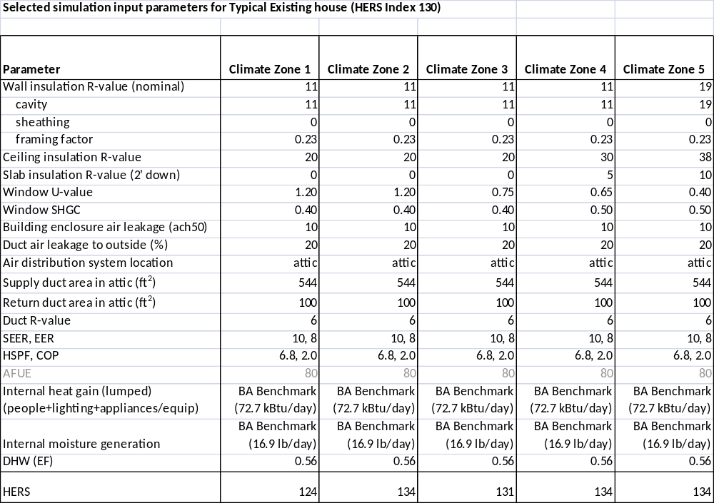

HERS Reference House (HERS Index ≈100)
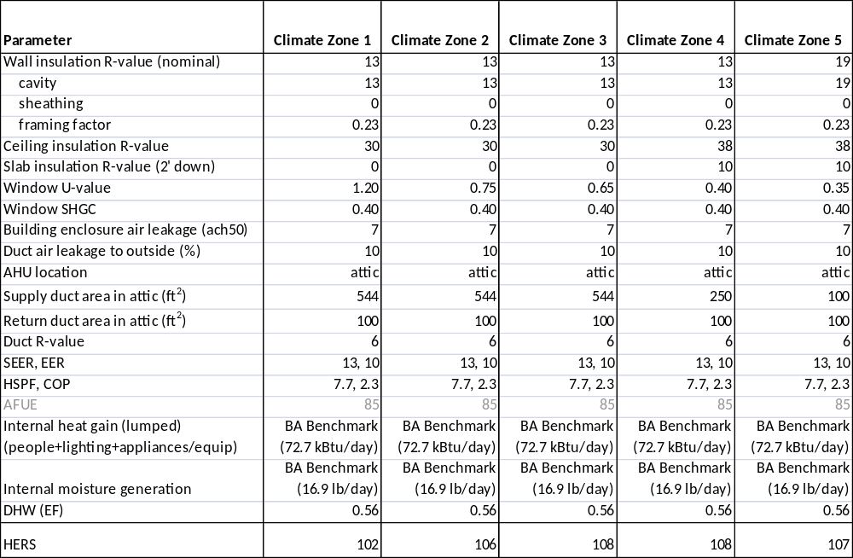

Energy Star House (HERS Index ≈85)
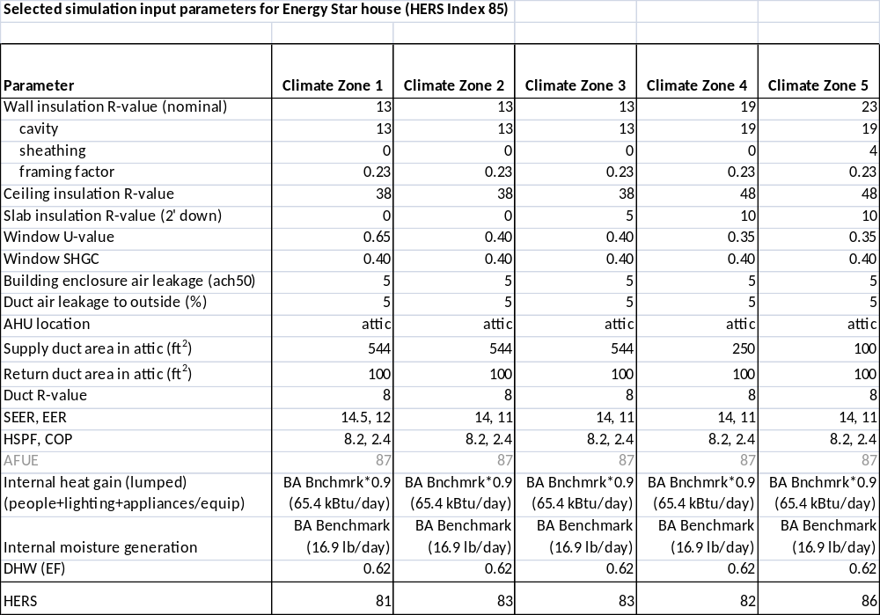

Builders Challenge House (HERS Index ≈70)
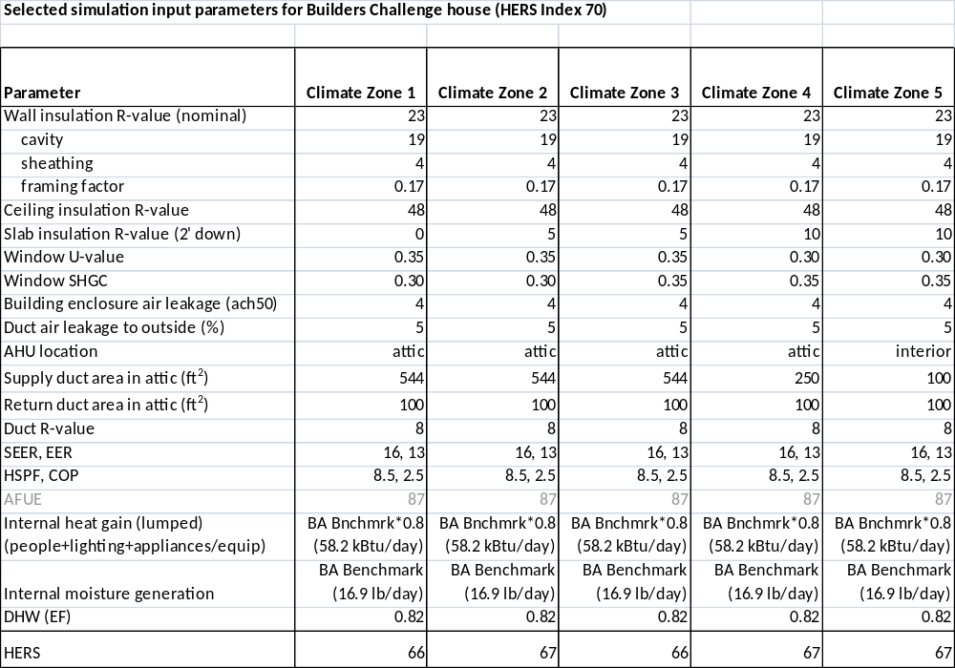

Building America House (HERS Index ≈50)
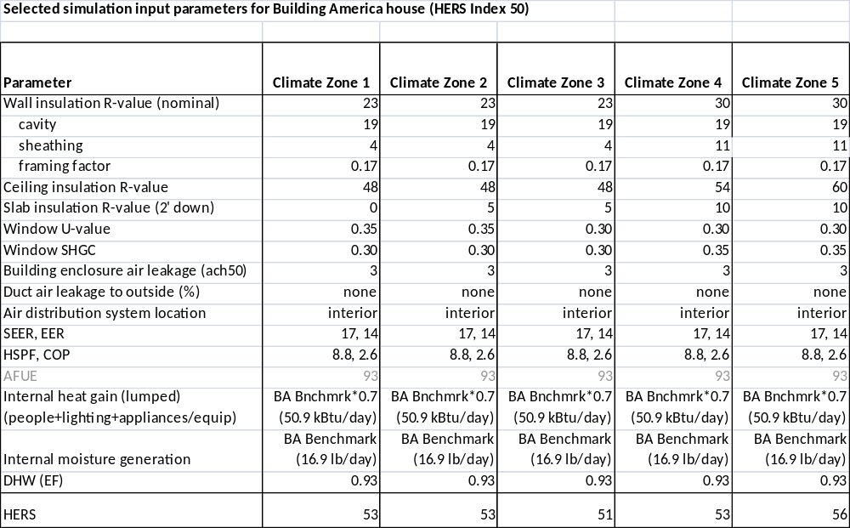

Appendix B. Detailed Summary of Parametric Simulation Cases

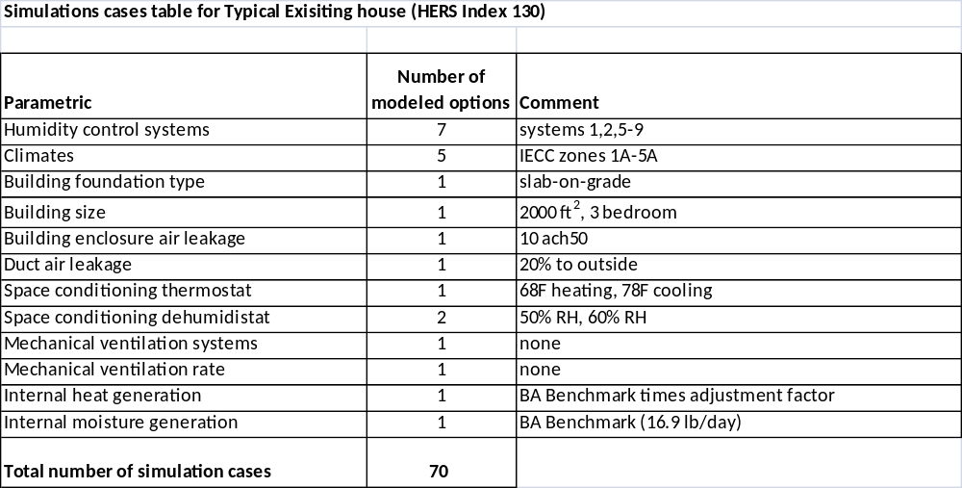

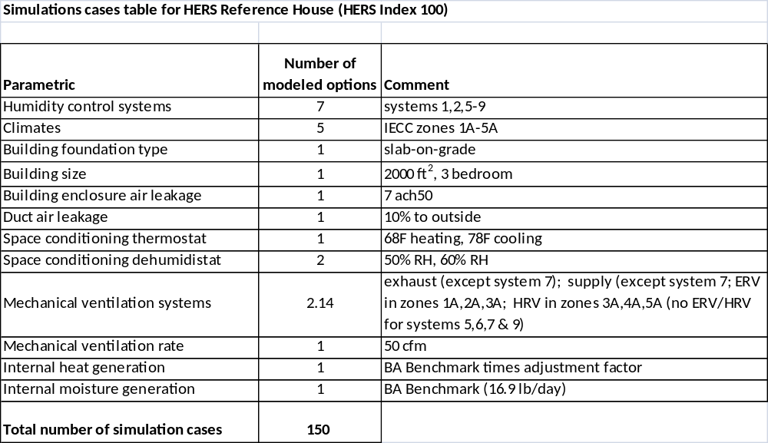

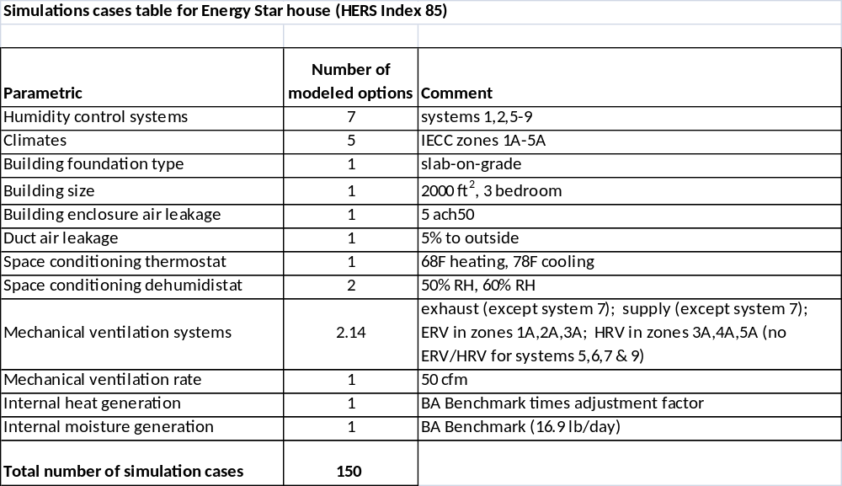

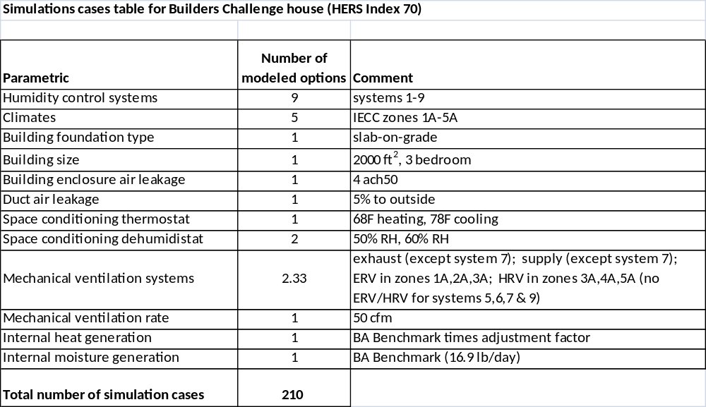

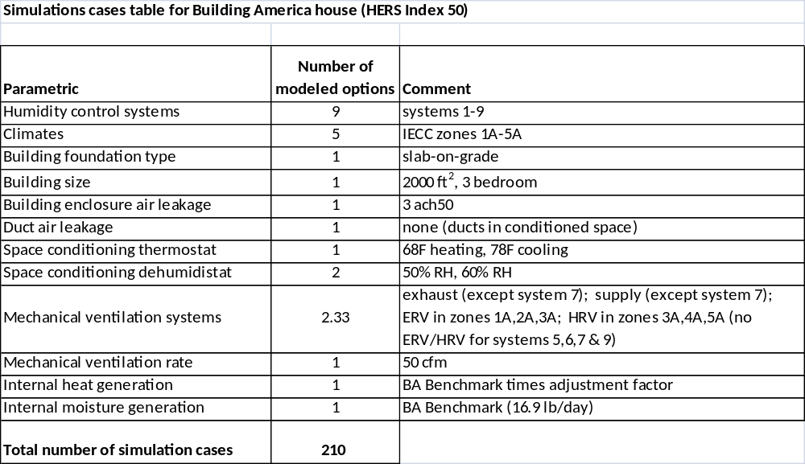

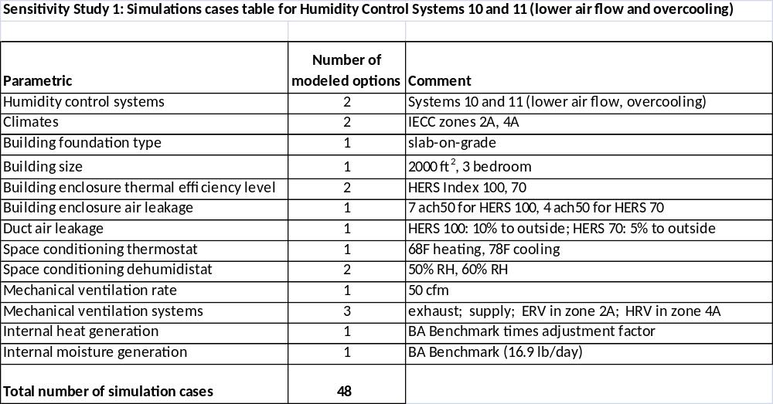

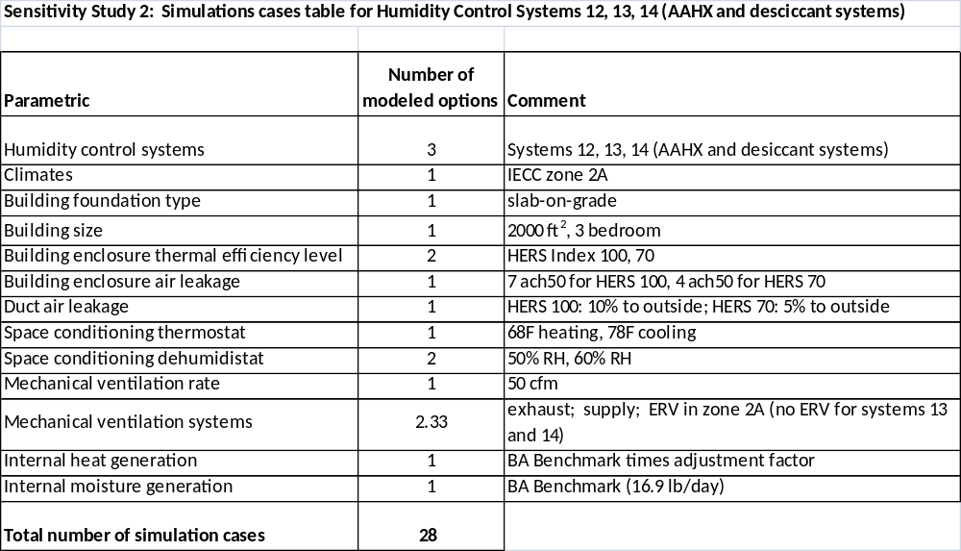

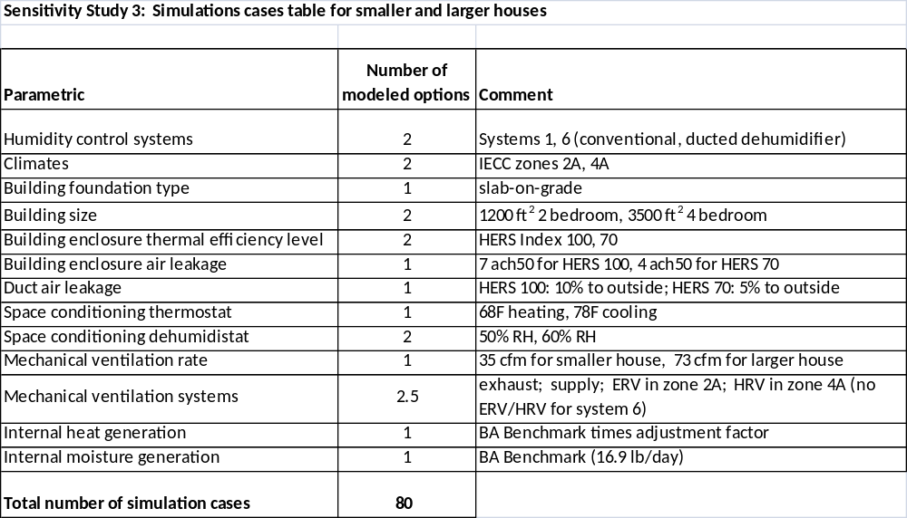

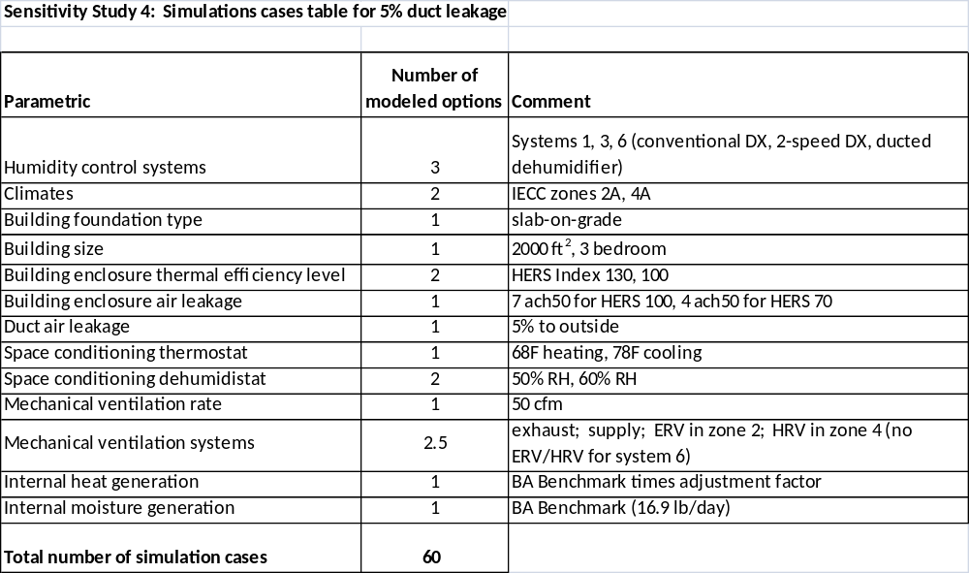

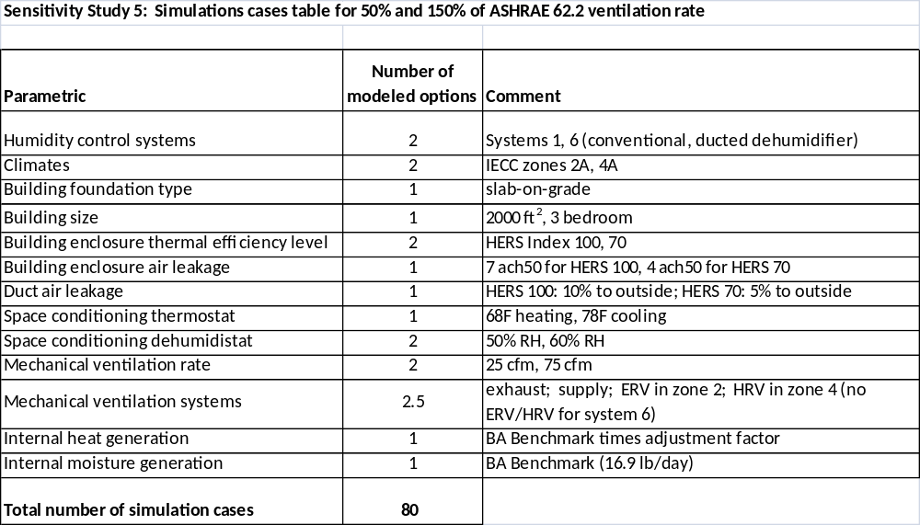

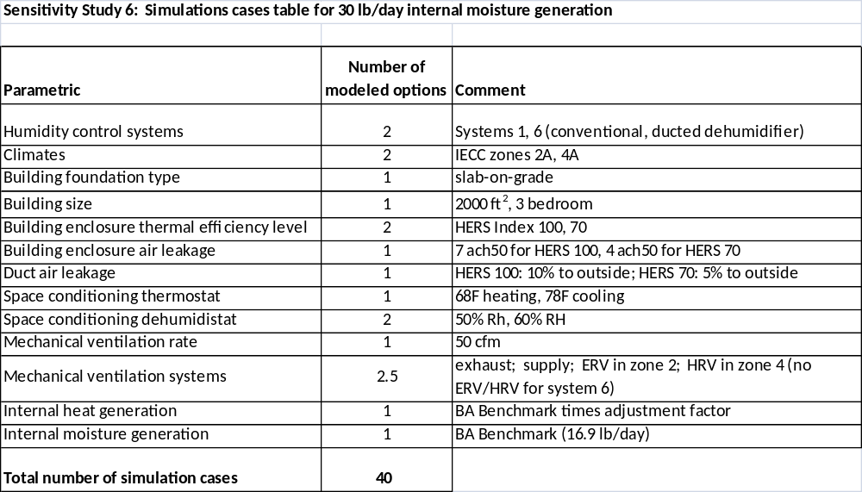

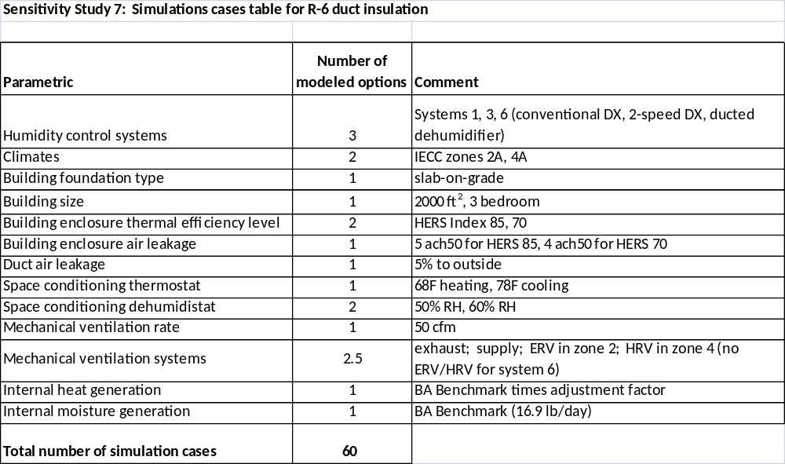

A publicly-available version of TRN-ResDH is available at http://www.cdhenergy.com/trn-resdh2/. An updated version and documentation will be available to the PMS at the conclusion of this project.
Gross EER is total coil cooling capacity divided by compressor and condenser fan power at the nominal rating point: 95°F outdoors, 80°F/67°F entering coil and 450 cfm per ton supply air flow.
AHAM rating point is 80°F and 60%RH. Systems are rated at zero static.
Energy Factor (EF) of 3.3 L/kWh is based on the AHAM conditions of 80 F and 60% RH (though Munters does not specify what outdoor humidity and temperature are used to develop the rating, we have inferred it using the software tool). The Munters HD unit also goes by the name of the Model DC120 or the DryCool Mini. Novelaire makes a similar unit (Comfort 300) which has a rated EF of EF of 2.6 L/kWh.

